MULTIMETER DIFFERENT MODES AND WHOLE FUNCTIONALITY

A multimeter is a device which is used to measure voltage,current and resistance.There are two types of multimeter:

1.Analog Multimeter

2.Digital Multimeter

Digital multimeters are of three types out of which fluke digital multimeter is most commonly used.

Different parts of multimeter include:

**1.Display**

**2.Selection knob**

**3.Ports**

**1.Display**:it generally displays the value which we are going to measure using the multimeter,it can display the value of resistance,current or even voltage across the two terminals,during overloading multimeter generally displays 1 as its value

2.Selection Knobs:Selection knob basically helps us to measure three different things,it helps us to measure current,resistances and also voltage.

Probes are connected in two different ports generally the negative or black one is connected in COM and positive one is connected in the mAV port,we represent black wire with the negative or the ground one and red wire with the positive.

**3.PORTS:**

There are many different [types of probes](https://www.sparkfun.com/search/results?term=banana&what=products) available for multimeters. Here are a few:

* [Banana to Alligator Clips](https://www.sparkfun.com/products/509) : These are great cables for connecting to large wires or pins on a breadboard. Good for performing longer term tests where you don’t have to have to hold the probes in place while you manipulate a circuit.
* [Banana to IC Hook](https://www.sparkfun.com/products/506) : IC hooks work well on smaller circuits.

Alligator clips are generally used as they get connect better to the the different circuit components.

It can be used to measure :

**1.Voltage**

**2.Current**

**3.Resistance**

Voltage:It is generally used to measure voltage,first of all we set up a particular voltage in voltmeter suppose 20volts in this case,If the value measured is less then the actual value then it displays that particular value.

**OVERLOADING**:In this case if value of the voltage across two nodes in a particular circuit is more than the set up value then it displays 1 means the circuit is overloaded

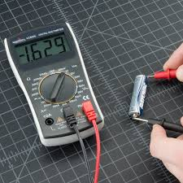

CURRENT:The most trickiest is to measure current using the multimeter,while measuring the current through the multimeter the multimeter becomes the part of the circuititis connected across the circuit and even the current flows through the multimeter so the resistance of multimeter should be as small as possible,great care should be taken so that fuse of multimeter should not be blown when excessive current passes through the multimeter.

IMAGE SHOWING HOW TO MEASURE CURRENT USING MULTIMETER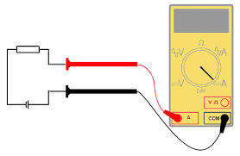

Resistance:It can also used to measure resistance,we first set up the resistance value which is required to be measured,The resistance value can be setup in form of Kilohms and ohms,WE CONNECT THE TWO PROBES OF MULTIMETER ACROSS THE TWO TERMINALS OF RESISTANES AND IT GIVES THE PARTICULAR READING.

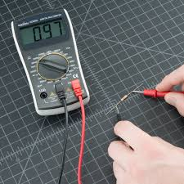

Continuity:It is also one of the major functions of multimeter to measure continuity,basically multimeter is used to measure the contimuity,it aso checks weather ther is break or not in wire,if the reading is close to zero or in some cases if buzzer beeps then there is no breakage in wire as it shows that the reading of mutimeter is continuos.

